Structured Supervision Folder

1. Supervision timeline guide
2. Case Plan
3. EBP Cheat Sheets
4. Carey Guide Tool Matrixes
5. EPICS Tools
   1. Decision Matrix
   2. Skills Cards
   3. Preparing for a Contact Session
   4. Behavior Chain
   5. Identifying Targets for Change
   6. Setting Goals
   7. Cost-Benefit Analysis
   8. Problem Solving Worksheet

**Structured Supervision**

**Delaware County Juvenile Court**

**Evidence Based Practice Resources:**

Carey Guides *– Access via website unless you have paper version license.* [*https://cgptools.com/*](https://cgptools.com/)

Carey Guides BITS – *Paper version.*

EPICS – *Access from EPICS training manual, this notebook or from website.* [*https://cechcloud.uc.edu*](https://cechcloud.uc.edu)

Forward Thinking Journals- *If you do not have any ask for current location. We have several on hand.*

* *Responsible Behavior*
* *Reentry Planning*
* *Handling Difficult Feelings*
* *Individual Change Plan*
* *What Got Me Here?*
* *Relationships and Communication*
* *Victim Awareness*

**Preparing for a Contact Session**

**CHECK-IN**

Need Areas: ____________________________________________________________________________________________________________________________________________

Compliance Areas: ____________________________________________________________________________________________________________________________________________

**REVIEW**

Short-term goals: _______________________

_______________________

_______________________

Long-term goals: _______________________

_______________________

_______________________

Groups/programs: ____________________________________________________________________________________________________________________________________________

Previous Skill: __________________________

Homework assignment: ___________________

**INTERVENTION**

Criminogenic Need: _______________________

Type of intervention: ______________________

Materials Needed: ________________________

**HOMEWORK**

Assignment based on intervention: ______________________________________________________________________

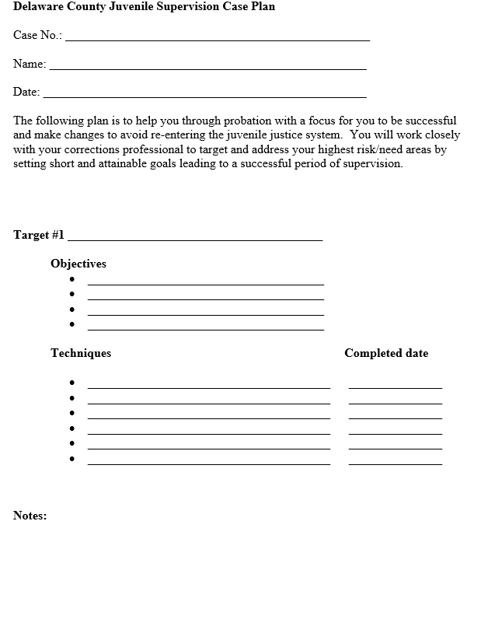

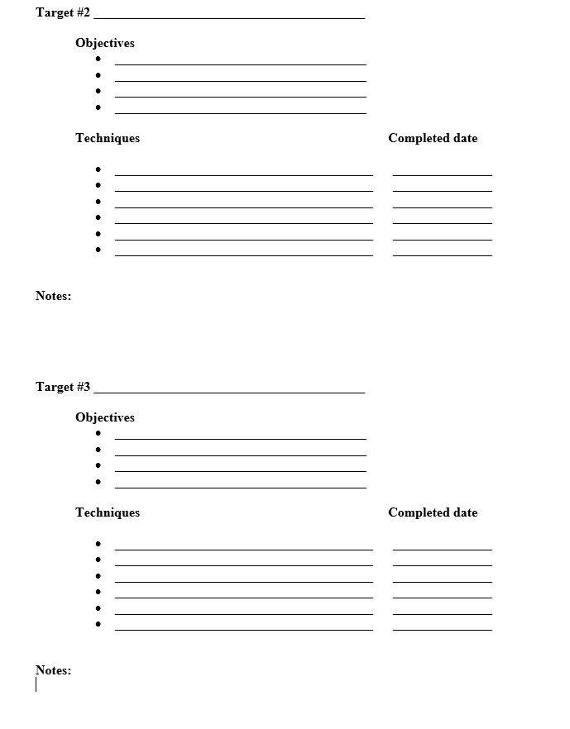

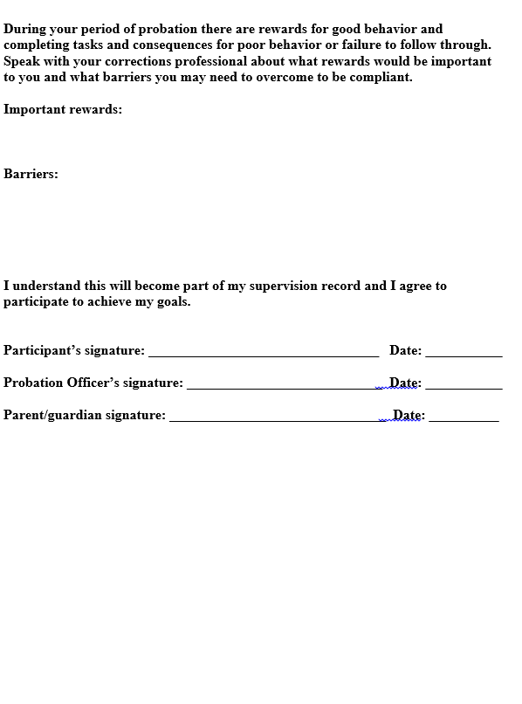

**Targeting Need Areas: A cheat sheet of evidence based practice tools.**

OYAS Domains

*Juvenile Justice History*

*Family and Living Arrangements*

*Peers & Social Network*

*Education & Employment*

*Pro-Social Skills*

*Substance Abuse, Mental Health and Personality*

*Values, Beliefs and Attitudes*

**Table of Contents**

|  |  |
| --- | --- |
| Target Skill Deficit | Page Number |
| **Aggression** | 3 |
| **Empathy** | 4 |
| **Family & Social Support** | 5 |
| **Juvenile Justice History** | 6 |
| **Leisure Time** | 7 |
| **Problem Solving** | 8 |
| **Relationships** | 9 |
| **Risk Taking & Impulsivity** | 10 |
| **Self-Efficacy & Goals** | 11 |
| **Substance Abuse** | 12 |
| **Values & Beliefs** | 13 |

**Aggression:** Learn new ways to manage your anger. Learn new ways to regulate your emotions. Learn to use techniques other than aggression to achieve your goals.

**Carey Guides: Blue: Criminogenic Needs Red: Case Management Issues**

Blue: Anger

1. Recognizing Physical Signs of Anger
2. Making Connections
3. Emotional Triggers
4. Changing Beliefs, Changing Consequences

Blue: Emotional Regulation

1. How Do I Respond?
2. Identifying Feelings
3. Decreasing Emotional Strength
4. Stop and Think
5. Feeling Good Without the Thrill

BITS: Thinking Traps, Overcoming Thinking Traps, Overcoming Automatic Responses

**Forward Thinking Journal:**  Handling Difficult Feelings, What Got Me Here

**EPICS:**  Decision Matrix – see Structured Skill Building

Skills Cards: #20, #26, #28, #30

(page 3)

**Empathy:**  Increase your empathy for victims, increase your compassion for others, learn how to practice the Golden Rule, think of the feelings of others before deciding to do something.

**Carey Guides: Blue: Criminogenic Needs Red: Case Management Issues**

Blue: Moral Reasoning

1. Assess Your Moral Reasoning
2. Moral Dilemas

Blue: Empathy

1. Assess Your Empathy
2. What Are the Effects?
3. Different Perspectives
4. Letter to the Victim

**Forward Thinking Journal:** Victim Awareness

**EPICS Skill Cards:** #13 Apologizing; #17 Understanding Feelings of Others

(page 4)

**Family and Social Support:** Develop and maintain healthy relationships with pro-social family members, establish a positive family support system, increase contact with pro-social family members, increase contact with pro-social friends.

**Carey Guides: Blue: Criminogenic Needs Red: Case Management Issues**

Blue: Overcoming Family Challenges

1. What’s Happening?
2. Changing the Response

Blue: Your Guide to Success

1. My Life Until Now
2. Increasing the Odds of My Success
3. Request for Stabilization Services

Red: Case Planning

1. Your Influences
2. Working Toward Your Goals

**Carey Guides BITS:** Decision Making worksheet regarding the effects of reducing contact with the negative influences within your family.

**Forward Thinking Journal:** Relationship Communication

**EPICS skills cards:** #15 Knowing Your Feelings, #16 Expressing Your Feelings, #17 Understanding the Feelings of Others, #18 Dealing with Someone Else’s Anger, #22 Asking Permission, #24 Helping Others, #26 Using Self-Control, #39 Dealing with Contradictory Messages

* Family Advocate involvement

* Mediation

* Family Counseling

(page 5)

**Juvenile/Criminal Justice History:**  Develop and maintain pro-social thinking patterns, make pro-social choices, reduce impulsive decision making, gain insight into how deviant or irrational thinking lead to criminal behavior, understand how bad decisions lead to negative consequences.

**Carey Guides: Blue: Criminogenic Needs Red: Case Management Issues**

Blue: Antisocial Associates

1. Thinking About Friendships
2. Changing My Associates

Blue: Antisocial Thinking

1. Thought-Feeling-Action Link
2. Thinking Patterns
3. Values and Beliefs
4. Defeating Harmful thoughts, Values, and Beliefs

Blue: Your Guide to Success

1. My Life Until Now
2. Increasing the Odds of My Success
3. Request for Stabilization Services

Blue: Problem Solving

1. Stop and Think
2. Brainstorm
3. Evaluate and Choose
4. Plan, Act, Assess, and Adjust
5. Solve On-the-Spot Problems

BITS: Thinking Traps

Overcoming Thinking Traps

Overcoming Automatic Responses

**EPICS:** Behavior Chain

Cost-Benefit Analysis

Problem Solving Worksheet

**EPICS Skill Cards:**  #22 Asking Permission, #29 Avoiding Trouble with Others; #40 Dealing with Accusations; #42 Dealing with Group Pressure

**Forward Thinking Journals:** Individual Change Plan

Responsible Behavior

(page 6)

**Leisure Time:** Develop and list pro-social outlets that you enjoy, participate in and report positive activities with pro-social family members, participate in and report positive activities with pro-social friends, become involved in a hobby that interests you.

**Carey Guides: Blue: Criminogenic Needs Red: Case Management Issues**

Blue: Prosocial Leisure Activities

1. Identifying Prosocial Leisure Activities
2. The Benefits of Prosocial Activities
3. Time Chart
4. Making a Plan

Blue: Your Guide to Success

1. My Life Until Now
2. Increasing the Odds of My Success
3. Request for Stabilization Services

Blue: Engaging Prosocial Others

1. Who Would You Call?
2. Expanding Your Prosocial Network

Blue: Emotional Regulation

Tool 5: Feeling Good Without the Thrill

Blue: Interpersonal Skills

Tool 3: Expanding Your Social Network

Red: Case Planning

1. Your Influences
2. Working Toward Your Goals

**BITS:** Decision Making

**EPICS:** Cost-Benefit Analysis

**EPICS Skills Cards:**  #2 Starting a Conversation, #3 Having a Conversation, #6 Introducing Self, #7 Introducing Others, #8 Giving a Compliment, #10 Joining In, #13 Apologizing, #22 Asking Permission, #33 Being a Good Sport, #34 Dealing with Embarrassment, #35 Dealing with Being Left Out, #38 Responding to Failure, #43 Deciding on Something to Do

(page 7)

**Problem Solving:** Identify multiple options to a problem, improve ways to solve a problem, learn steps needed for good problem solving

**Carey Guides: Blue: Criminogenic Needs Red: Case Management Issues**

Blue: Problem Solving

1. Stop and Think
2. Brainstorm
3. Evaluate and Choose
4. Plan, Act, Assess, and adjust
5. Solve On-The-Spot Problems

BITS: Problem Solving (in the moment problems)

EPICS: Problem Solving Worksheet

EPICS Skills Cards: #9 Problem Solving; #25 Negotiating; #44 Deciding What Caused a Problem; #48 Arranging Problems by Importance; #49 Making A Decision

(page 8)

**Relationships:** Develop and maintain healthy relationships with pro-social friends, establish a positive support system, increase contact with pro-social friends, associate with community members who stay out of trouble.

**Carey Guides: Blue: Criminogenic Needs Red: Case Management Issues**

Blue: Interpersonal Skills

1. Your Social Network
2. Getting Along with Others
3. Expanding Your Social Network
4. Using the STOP Method to Resolve Conflicts

Blue: Antisocial Associates

1. Thinking About Friendships
2. Changing My Associates

Blue: Engaging Pro-Social Others

1. Expanding Your Prosocial Network

Blue: Your Guide to Success

1. My Life Until Now
2. Increasing the Odds of My Success
3. Request for Stabilization Services

**Forward Thinking Journal:** Relationship Communication

**EPICS skills cards:** #1 Listening, #2 Starting a Conversation, #3 Having a Conversation

* Attend pro-social outings

* Attend girls/guys group

(page 9)

**Risk Taking and Impulsivity:** Learn how to determine positive and negative consequences prior to acting on a thought. Learn how to plan your daily activities in an efficient manner.

**Carey Guides: Blue: Criminogenic Needs Red: Case Management Issues**

Blue: Emotional Regulation

1. How Do I Respond?
2. Identifying Feelings
3. Decreasing Emotional Strength
4. Stop and Think
5. Feeling Good Without the Thrill

Blue: Problem Solving

1. Stop and Think
2. Brainstorm
3. Evaluate and Choose
4. Plan, Act, Assess, and Adjust
5. Solve On-the-Spot Problems

Red: Behavioral Techniques

1. Conducting a Practice Session
2. Applying New Skills

Red: Violence & Lethality (if applicable for someone who has violent outbursts)

1. STORC
2. Recognizing Relapse Cycles

Carey Guides BITS: Thinking Traps, Overcoming Thinking Traps, Overcoming Automatic Responses regarding a previous impulsive decision made that had negative consequences.

Carey Guides BITS: Problem Solving worksheet to prepare for a possible upcoming situation.

**Forward Thinking Journal:**  Responsible Behavior

**EPICS:**  Decision Matrix – see Structured Skill Building

Problem Solving Worksheet

Skills cards: #26, #29

(page 10)

**Self- Efficacy:**  Understand how you can achieve a goal, learn how decisions can improve an outcome, learn how to control what happens to you.

**Carey Guides: Blue: Criminogenic Needs Red: Case Management Issues**

Blue: Your Guide to Success

1. My Life Until Now
2. Increasing the Odds of My Success
3. Request for Stabilization Services

Red: Case Planning

1. Your Influences
2. Applying New Skills

**Forward Thinking Journal:**  Individual Change Plan

**EPICS:**

* Identifying Targets for Change
* Problem Solving Worksheet
* Skills Cards: #9 Asking for Help; #12 Following Instructions; #21 Rewarding Yourself; #45 Setting a Goal; #46 Deciding on Your Abilities; #48 Arranging Problems by Importance; #49 Making a Decision

(page 11)

**Substance Abuse:** Develop skills to maintain a substance free lifestyle, learn new ways to stay substance free, reduce your reliance on drugs and alcohol to help you cope with stressful situations, remain sober and develop friends who also enjoy sobriety.

**Carey Guides: Blue: Criminogenic Needs Red: Case Management Issues**

Blue: Substance Abuse

1. Understanding Your Drug or Alcohol Use
2. Moving Toward Change
3. People, Places, and Feelings
4. Recovering from a Relapse

Blue: Prosocial Leisure Activities

Tool 4: Time Chart

Red: Case Planning

1. Your Influences
2. Working Toward Your Goals

Red: Meth Users (applies to all substance users)

1. Stages of Recovery
2. Surviving the Wall
3. Identifying Triggers
4. Planning Your Day
5. How Am I Doing?

Red: Co-Occurring Disorders (if both mental health and substance abuse)

1. Understanding Your Mental Health and Substance Abuse Conditions
2. Asking Questions
3. Getting Organized
4. Identifying Patterns

**Forward Thinking Journal:** Substance Abusing Behavior

**EPICS:** Cost-Benefit Analysis (may need to use multiple times)

Attend & complete AoD counseling

(page 12)

**Values and Beliefs:** Live by values that keep you out of trouble, learn how your beliefs and values effect what you do, replace anti-social values with pro-social values.

**Carey Guides: Blue: Criminogenic Needs Red: Case Management Issues**

Blue: Your Guide to Success

1. My Life Until Now
2. Increasing the Odds of My Success
3. Request for Stabilization Services (if needed)

Blue: Antisocial Thinking

1. Thought-Feeling-Action Link
2. Thinking Patterns
3. Values and Beliefs
4. Defeating Harmful Thoughts, Values, and Beliefs

Blue: Moral Reasoning

1. Assess Your Moral Reasoning
2. Moral Dilemmas

**Carey Guides BITS:** Decision Making (regarding changing your values)

**Forward Thinking Journals:**  What Got Me Here?

Responsible Behavior

**EPICS:**

Decision Matrix

1. TAPES and COUNTERS (identify antisocial thinking and replace with prosocial thinking)
2. Behavior Chain
3. Thinking Report

**EPICS skill cards:** #49 Making a Decision

(page 13)



**Using Carey Guide Tools to Address Criminogenic Needs/Responsivity and Stabilization Factors**

QR code



Carey Guides Index – QR code

**Supervisor Forms**

**Probation: Internal File Audit form**

Youth name:

PO name:

Supervisor:

**Criteria for Admission:**

|  |  |
| --- | --- |
| Age of juvenile upon admission: _________ |  |
| Adjudicated of charge(s) | Y N |
| PDI complete and in file | Y N |
| OYAS Disposition Tool Moderate or High risk | Y N |
| OYAS Override was necessary to place on probation | Y N |

**Best Practices:**

|  |  |
| --- | --- |
| Terms of Probation signed within 5 days Note: | Y N |
| Case plan established within 30-60 days | Y N |
| Case plan signed by Juvenile, PO and available family/copy to family | Y N |
| OYAS re-administered and in file every 6 months Note: | Y N |
| Use of Evidence Based Practices documented | Y N |
| Use of incentives documented | Y N |
| Use of informal interventions documented | Y N |
| Violation of Probation has been filed   * Documentation to support the need for a VOP | Y N  Y N |

**Minimum Contact standards**

**High**

***Type* *Status* *Notes***

|  |  |  |
| --- | --- | --- |
| 1 face to face per week min. 30 minutes on EBP | Y N |  |
| 1 home visit/month w/walk through | Y N |  |
| 1 parent/guardian contact per week | Y N |  |
| 1 collateral contact per week | Y N |  |
| 1 team meeting monthly | Y N |  |
| Drug screening as appropriate | Y N |  |

**Moderate**

***Type Status Notes***

|  |  |  |
| --- | --- | --- |
| 1-2 face to face every 1-2 weeks min. 30 min on EBP | Y N |  |
| 2 home visit per month, 1 with walk-through | Y N |  |
| Bi-weekly contact with parent/guardian | Y N |  |
| 1 collateral contact bi-weekly | Y N |  |
| 1 team meeting monthly (moderate-high OYAS score) | Y N |  |

**Low**

***Type Status Notes***

|  |  |  |
| --- | --- | --- |
| 1-2 face to face per month min. 30 min on EBP |  |  |
| 1 home visit w/walk through every 3 months |  |  |
| Parent/guardian contact 3X/month |  |  |

**Terminations**

|  |  |
| --- | --- |
| Termination form complete and approved | Y N |

**Supervisor Observation Form**

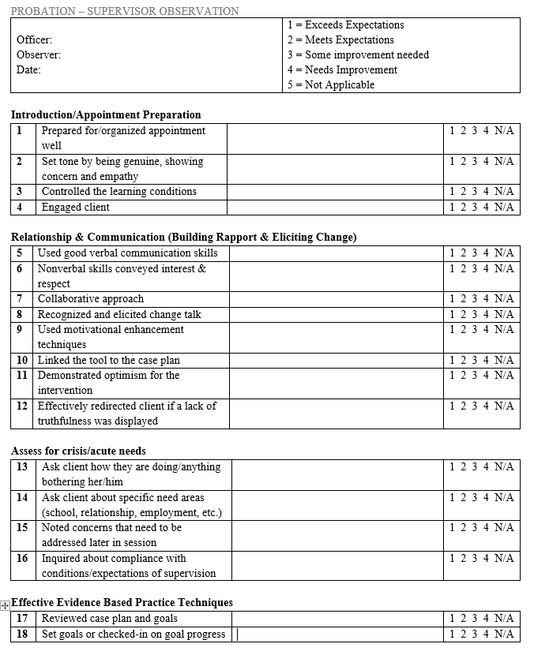

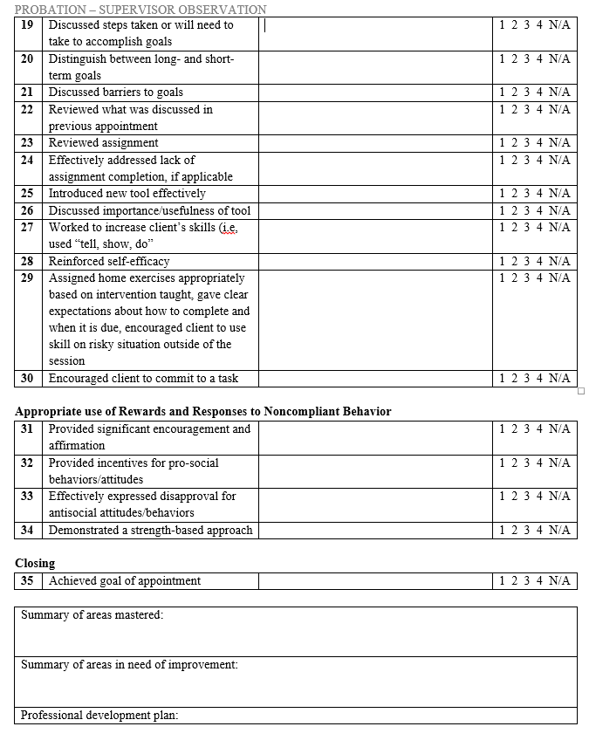

**Supervision: Case Staffing form**

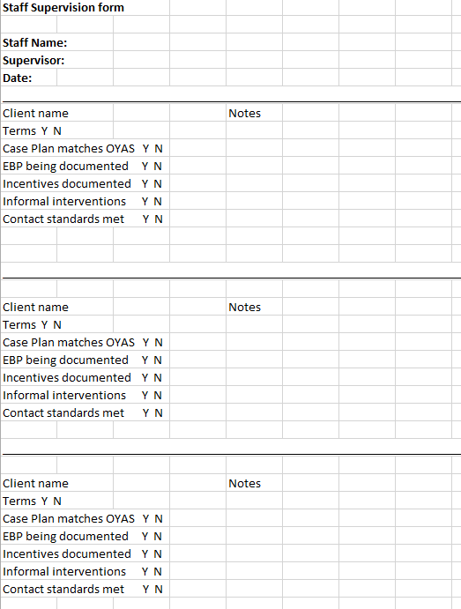

**Case Termination Approvals**

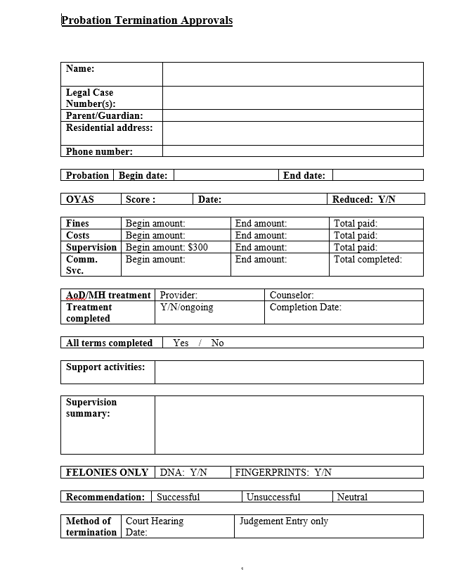

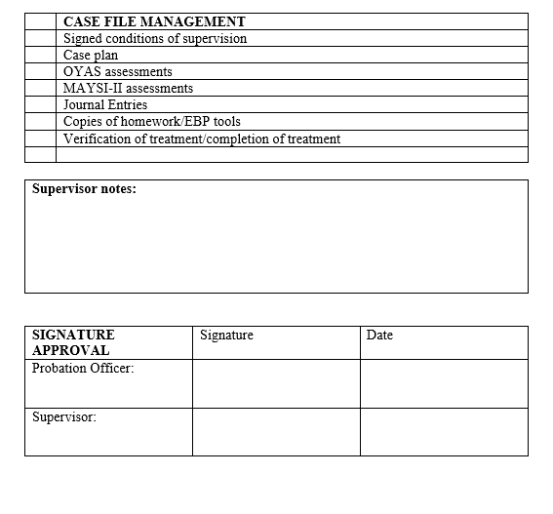

Kara J. Moore

Chief Probation Officer

Delaware County Juvenile Court

145 N. Union St.

Delaware, Ohio 43015

740-833-2638

kmoore@co.delaware.oh.us